Computer Science


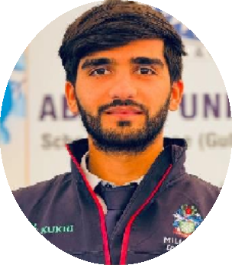
Summary

I would dedicate myself towards the achievement of company’s objectives, whole being a part of it and would carry out my duty’s responsibility, while maintaining excellent interpersonal relationships with my fellow workers.
Hazrat Ullah

Personal Information
F-Name : Qudrat Ullah
N-I-C : 17301-9390146-5
D-O-B : 04/06/1998
Domicile : Peshawar

Contact
Address: 
OutSide Gunj Gate, Dora Road Akhoon Abad Number# 05, Street Number# 4th, Peshawar City
Phone: 

Skill Highlights

- Strong decision maker  - Complex problem solver  - Team Leader  - Patience | - Innovative  - Service-focused  - Written fluency  - Teaching

Education

Certificate | Division | Year | Board / University | Percentage  / GPA
Matric | 2nd | 2016 | Peshawar | 65.09 %
FSC | 2nd | 2018 | Peshawar | 62.27 %
BSCS | 1st | 2023 | Abasyn University Peshawar | 3.73 (GPA)
DIT | 1st | 2018 | Technical Board Peshawar | 84.07 %

+92 302-911-383-0
+92 317-973-500-5
Email:
hazratullah777huk@gmail.com

Languages

English Urdu Pashto

Certifications
- Quiz competition (Computer Science)
- Debugging competition (Python Programming Language)

- Diploma in Information Technology (DIT)
- Hardware (Obstrical Avoider Robot) etc.

Experience

Teaching:

  - Allied school System city campus
from May 2023 To May 2024 as a computer science Subject teacher.

Abasyn University School
From 21-Augest-2024 To 06- October – 2025 as a computer science subject teacher.

COSMOS Institute of Computer Sciences
since 10th,April 2023 as a DIT Teacher and IT instructor.

Qurtuba University Peshawar:
Worked as an IT Assistant from 06-October-2025 To 10-November-2025.

CECOS University Peshawar:
Since 3rd – November – 2025 as a junior lecturer in computer science department.

Competitions

Participating in national competitions :-

- Visio Spark 2022(19 Edition) COMSIT
Wahcant:-
  - Quiz Competition
  - Debugging Competition
- SZABIST 2023(5th Edition) Islamabad:-
- Obstrical Avoider Robotics
- Visio Spark 2023(20 Edition) COMSIT
Wahcant:-
- Quiz Competition

